**Name: Soumyadeep Ganguly**

**Roll. No: 24MDT0082**

**Course: M.Sc. in Data Science**

**Assessment 2**

**PMDS506P Database Management systems.**

**Q1. Create a table EMPLOYEES with the attributes EMPNO, NAME, JOB, HIREDATE, SAL, DEPTID and populate it with the following data.**

1. **Find the minimum salary being given by the company.**

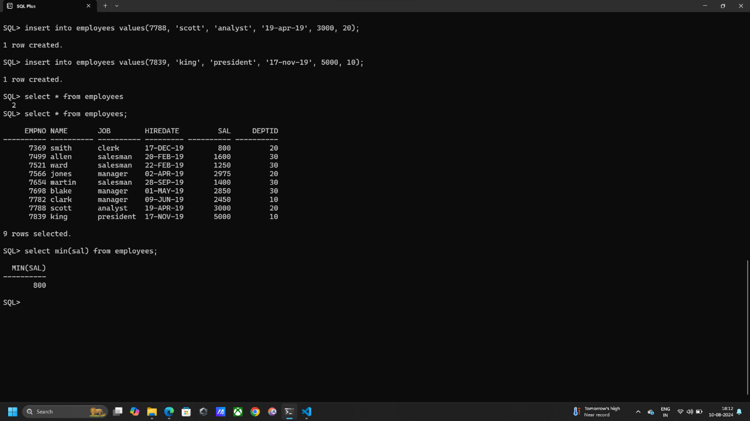SELECT MIN(SAL) FROM EMPLOYEES;

1. **List all employees with salary more than 1000 and who belong to department with id 30.**

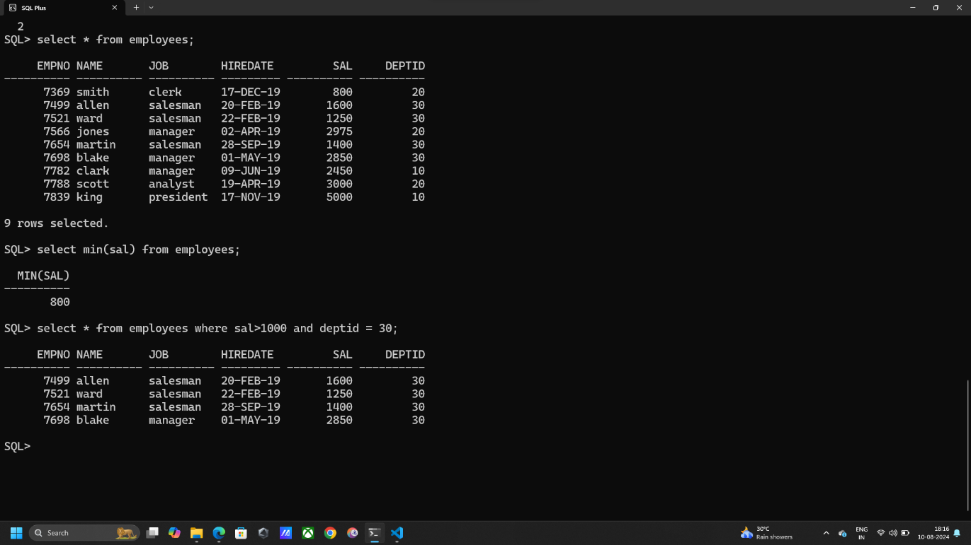SELECT * FROM EMPLOYEES WHERE SAL>1000 AND DEPTID = 30;

1. **Display the table entries with ascending order of their salary.**

SELECT * FROM EMPLOYEES ORDER BY SAL ASC;

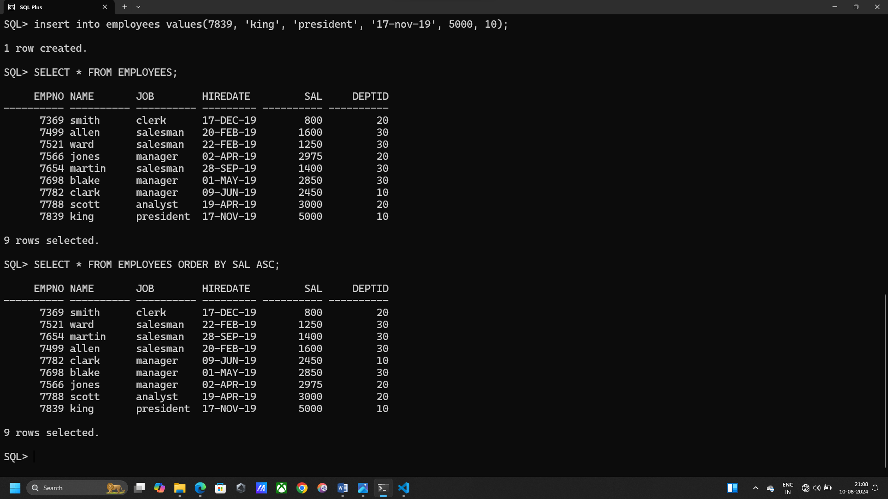

1. **Display all entries with salary > 2000 with the entries ordered in descending order with respect to the department ids.**

SELECT * FROM EMPLOYEES WHERE SAL > 2000 ORDER BY DEPTID DESC;

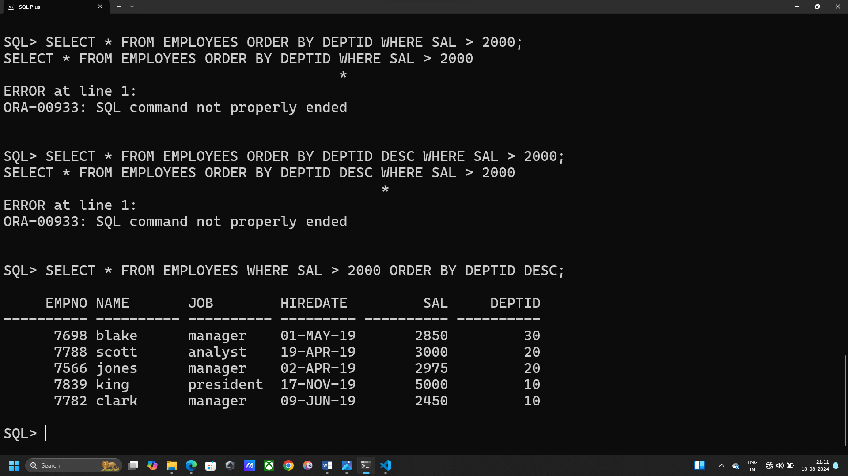

1. **List the names of the employee being given the maximum salary.**

SELECT * FROM EMPLOYEES

WHERE SAL = (SELECT MAX(SAL) FROM EMPLOYEES);

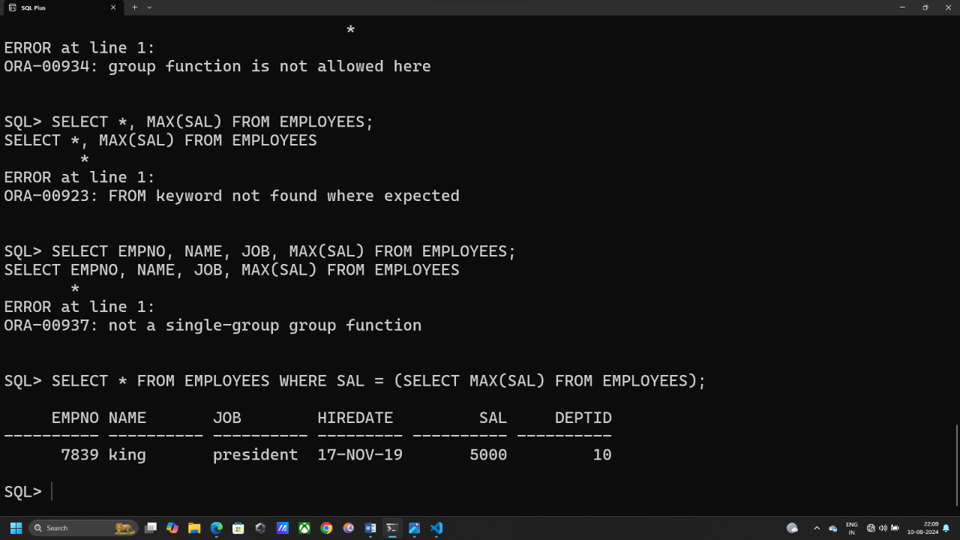

1. **Find the average salary being given by the company.**

SELECT AVG(SAL) FROM EMPLOYEES;

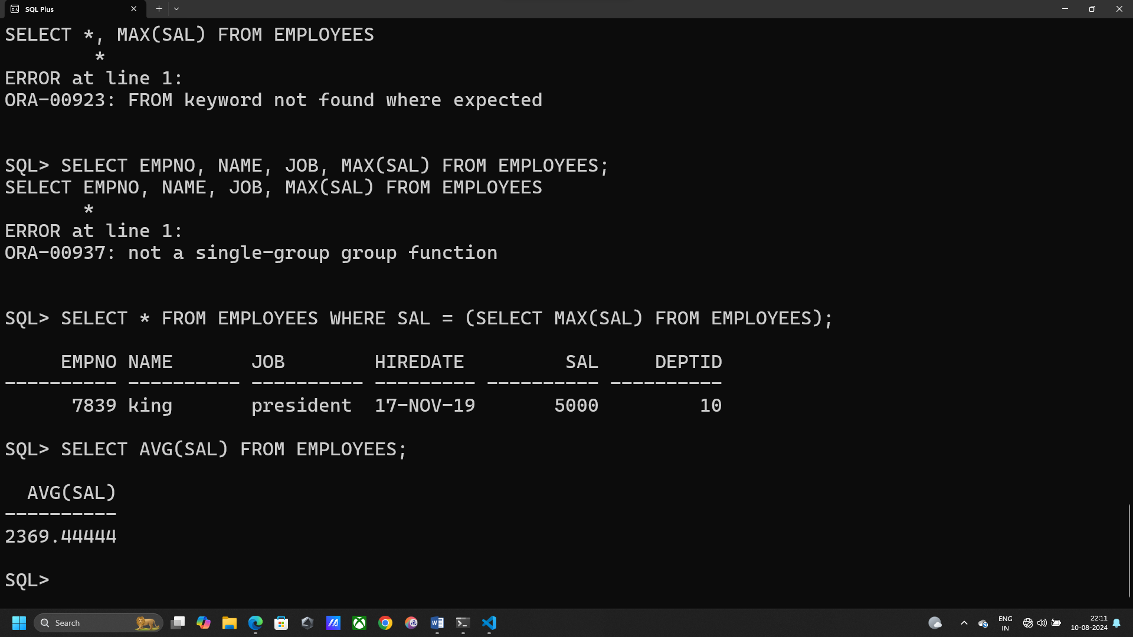

1. **Find the total count of all the employees.**

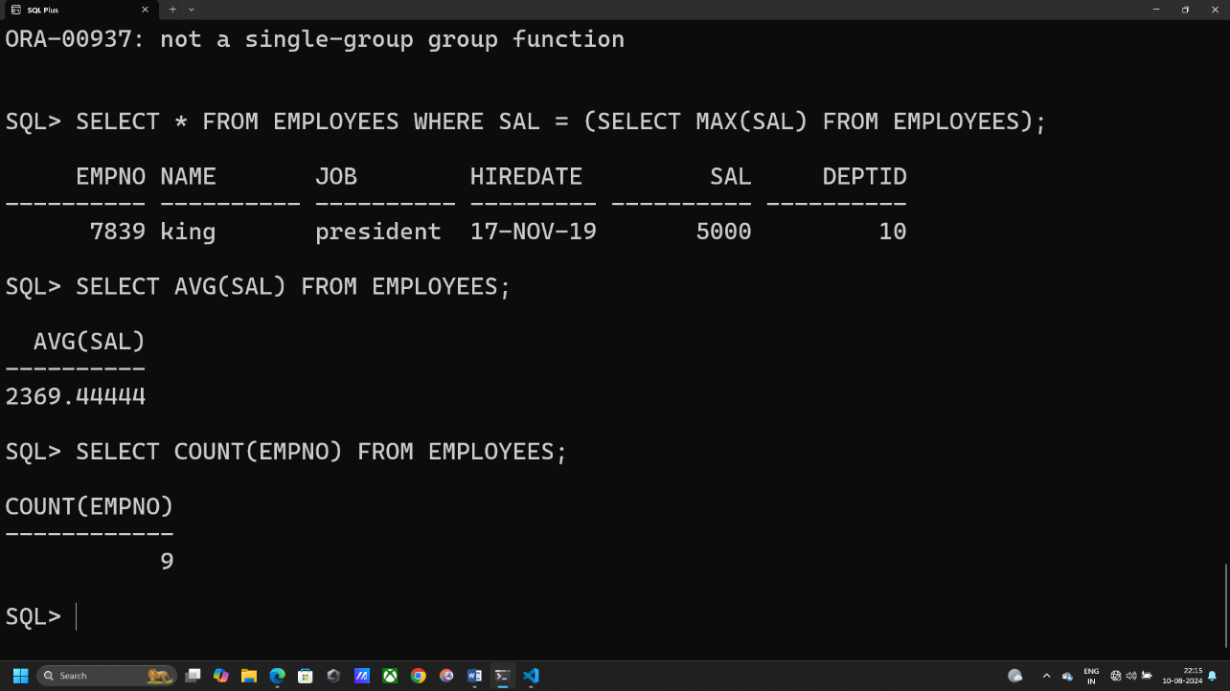SELECT COUNT(EMPNO) FROM EMPLOYEES;

1. **Find the total salary of all the employees.**

SELECT SUM(SAL) FROM EMPLOYEES;

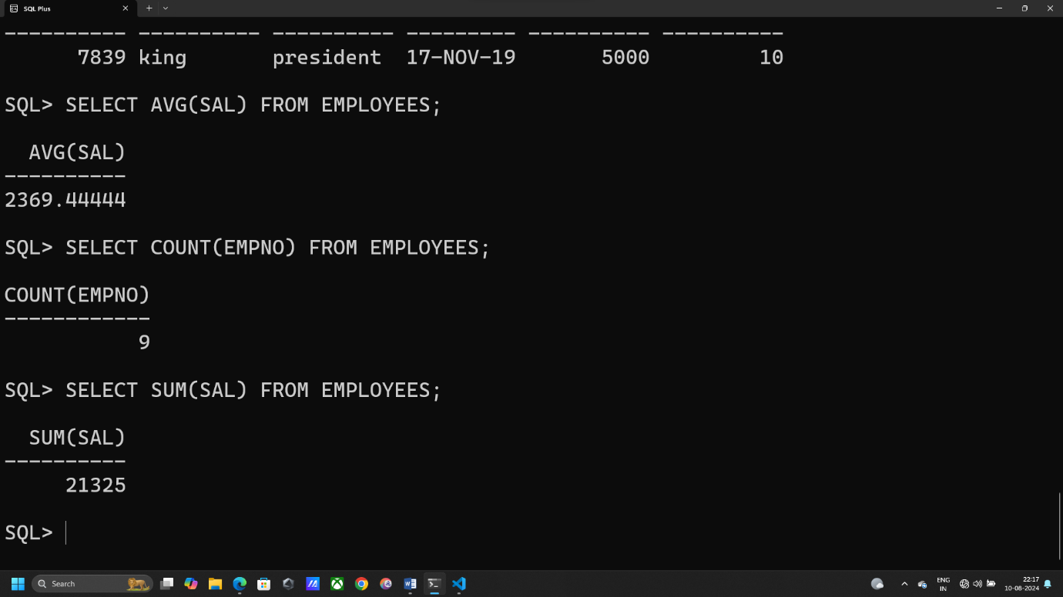

1. **Find the variance of the salary of the employees and display it.**

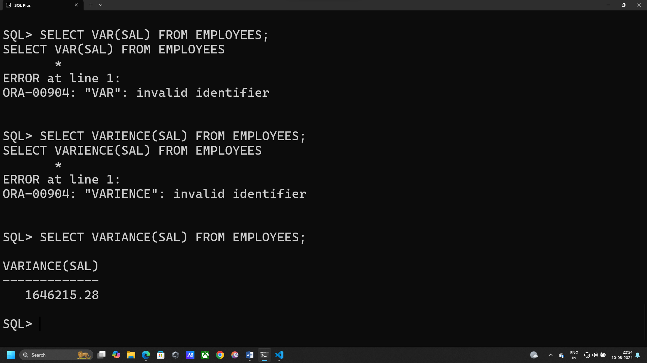SELECT VARIANCE(SAL) FROM EMPLOYEES;

1. **Find the total salary of all the employees of each department.**

SELECT DEPTID, SUM(SAL) FROM EMPLOYEES GROUP BY DEPTID;

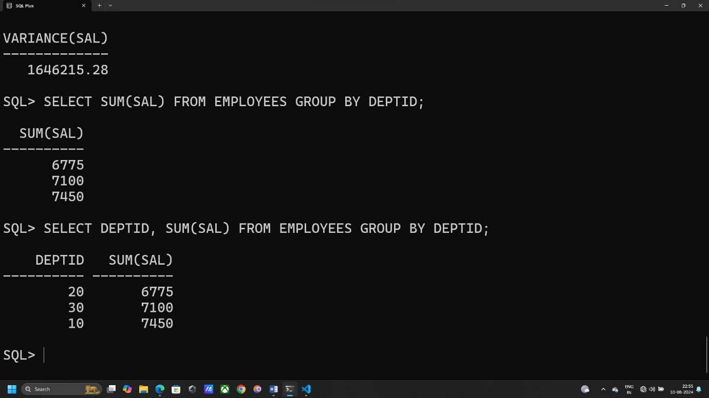

1. **Find the average salary of all the employees of each department**

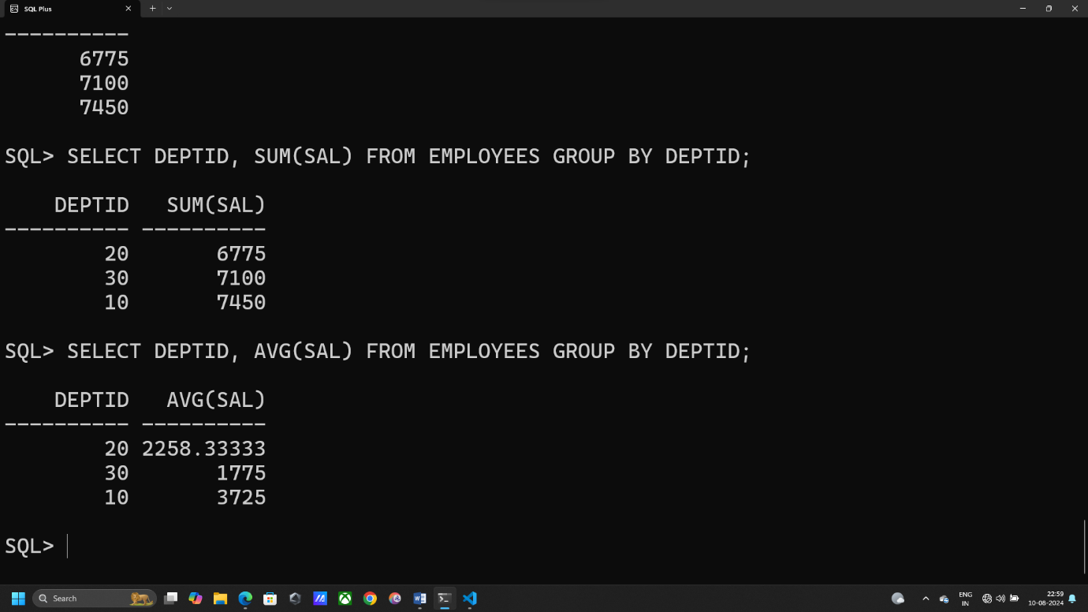SELECT DEPTID, AVG(SAL) FROM EMPLOYEES GROUP BY DEPTID;

1. **Find the count of the employees in each job type where the salary >1000.**

SELECT JOB, COUNT(EMPNO) FROM EMPLOYEES WHERE SAL>1000 GROUP BY JOB;

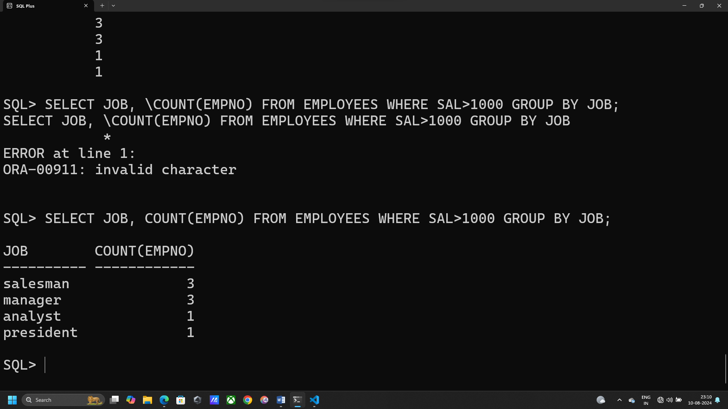

1. **Find the department id whose total number of employees is greater than 3.**

SELECT DEPTID, COUNT(EMPNO) FROM EMPLOYEES

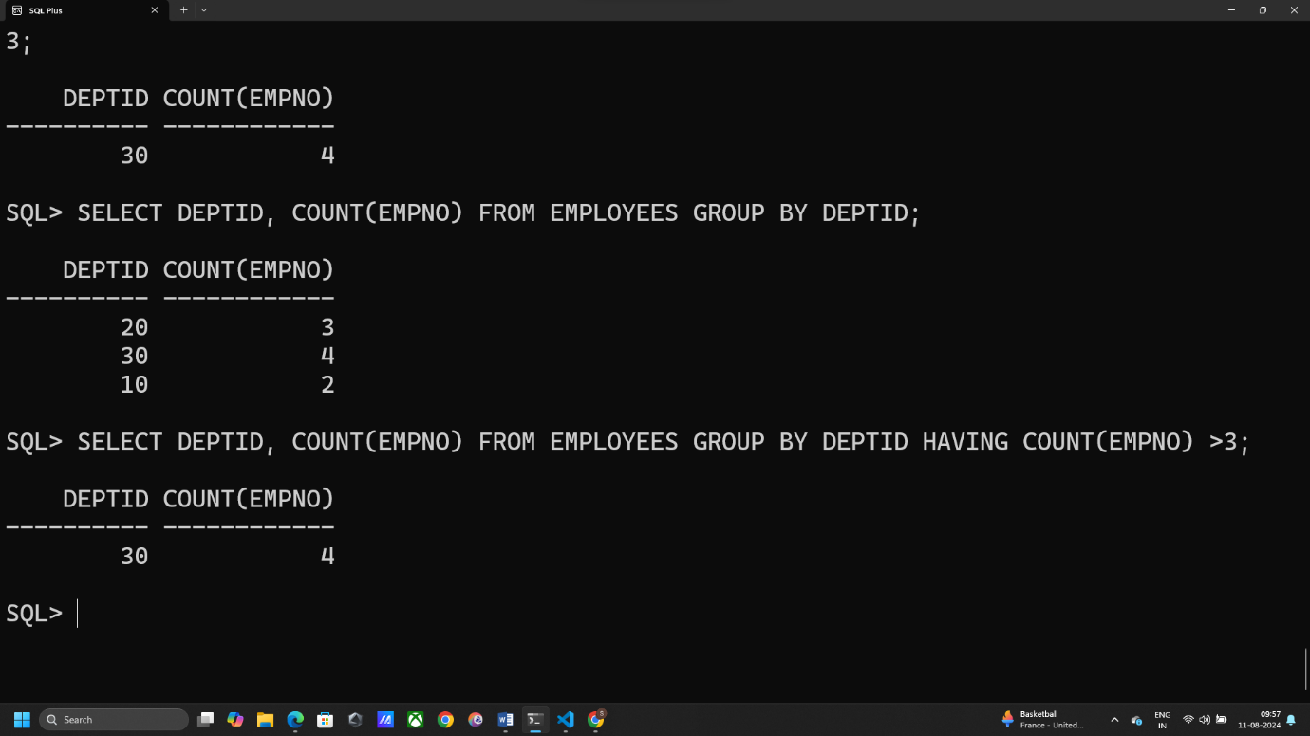GROUP BY DEPTID HAVING COUNT(EMPNO) >3;

1. **Find the next Monday of the hiredates of the employees who are clerks.**

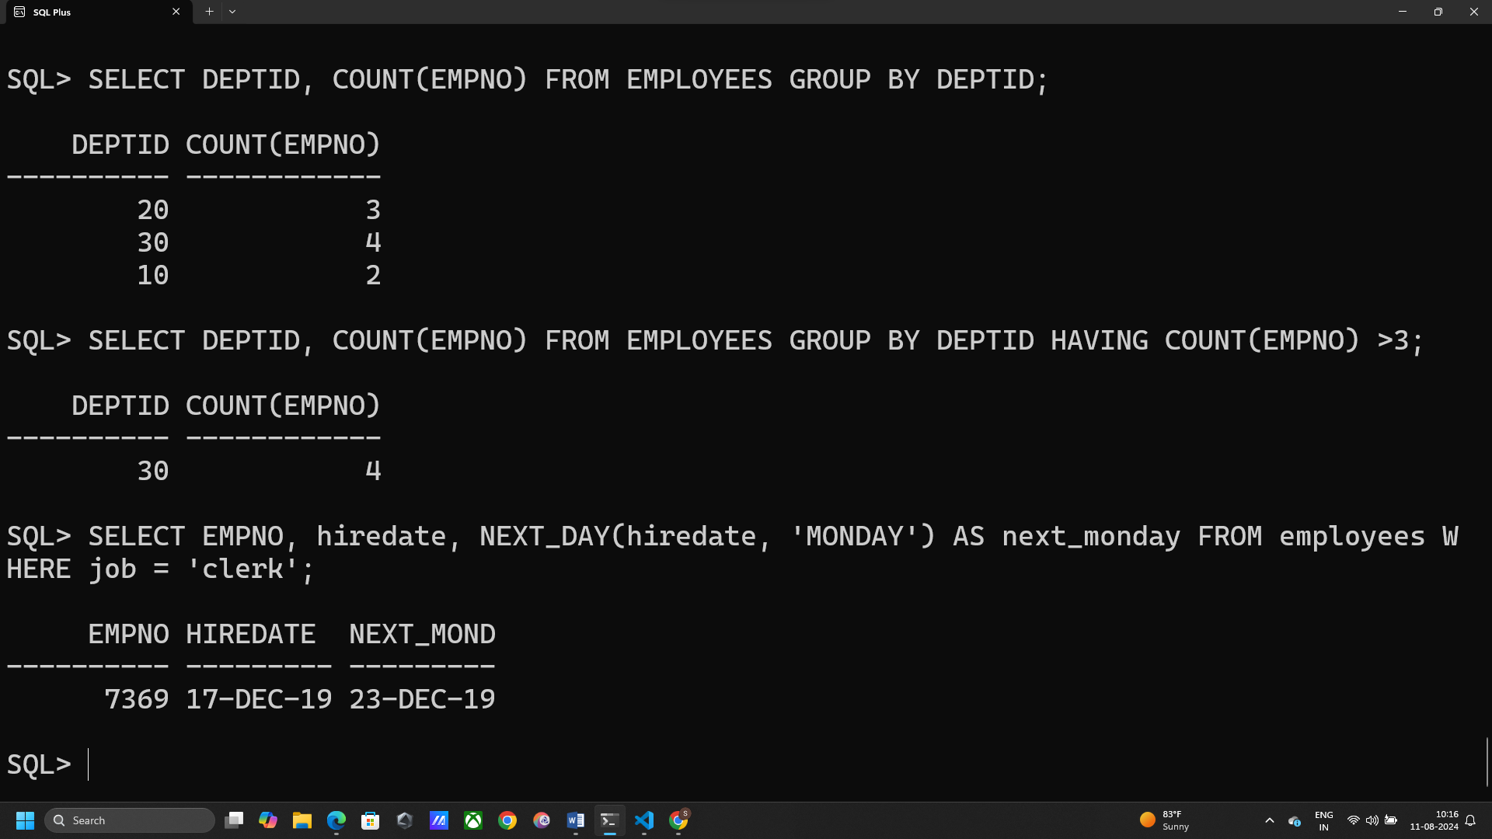SELECT EMPNO, hiredate, NEXT_DAY(hiredate, 'MONDAY') AS next_monday FROM employees WHERE job = 'clerk';

**Q2. Create the following table named as sailors, and answer the following.**

1. **List the distinct ratings among all the sailors.**

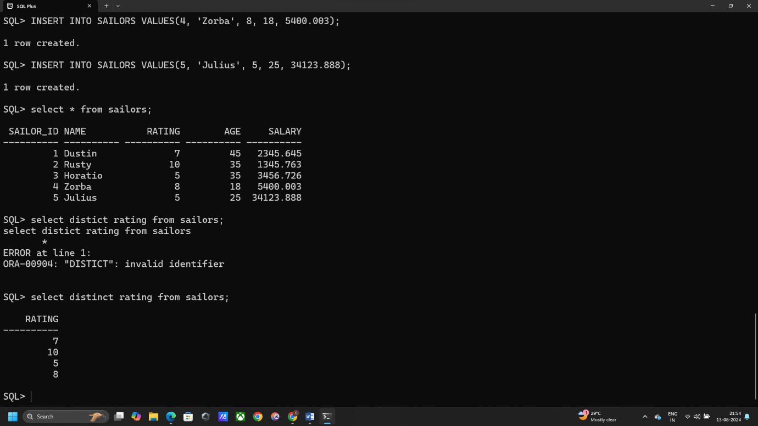select distinct rating from sailors;

1. **Write a query to round the salary of each sailor to the nearest whole number.**

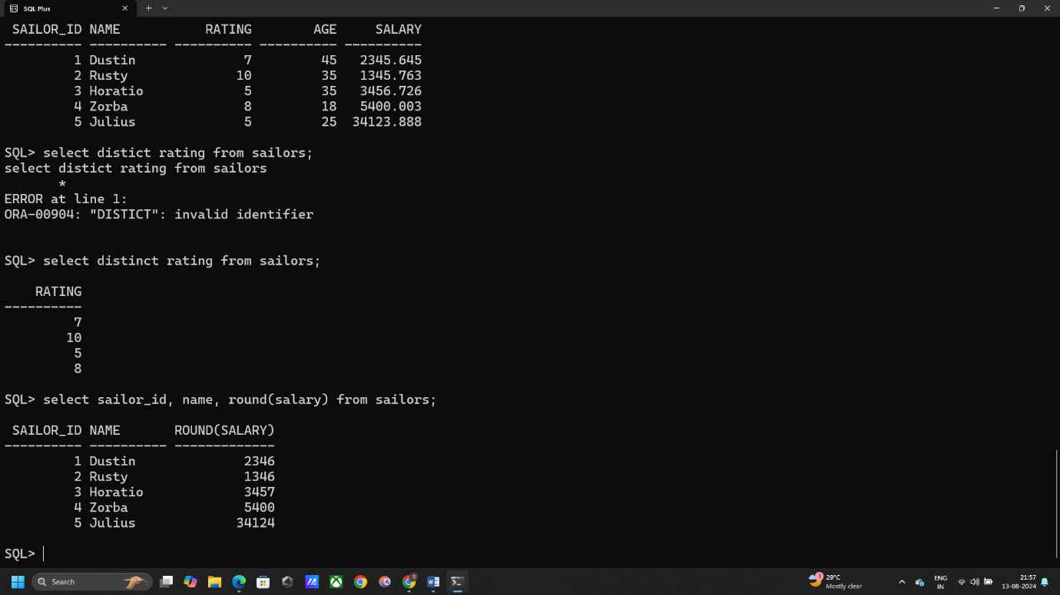select sailor_id, name, round(salary) from sailors;

1. **Write a query to truncate the salary of each sailor to two decimal places.**

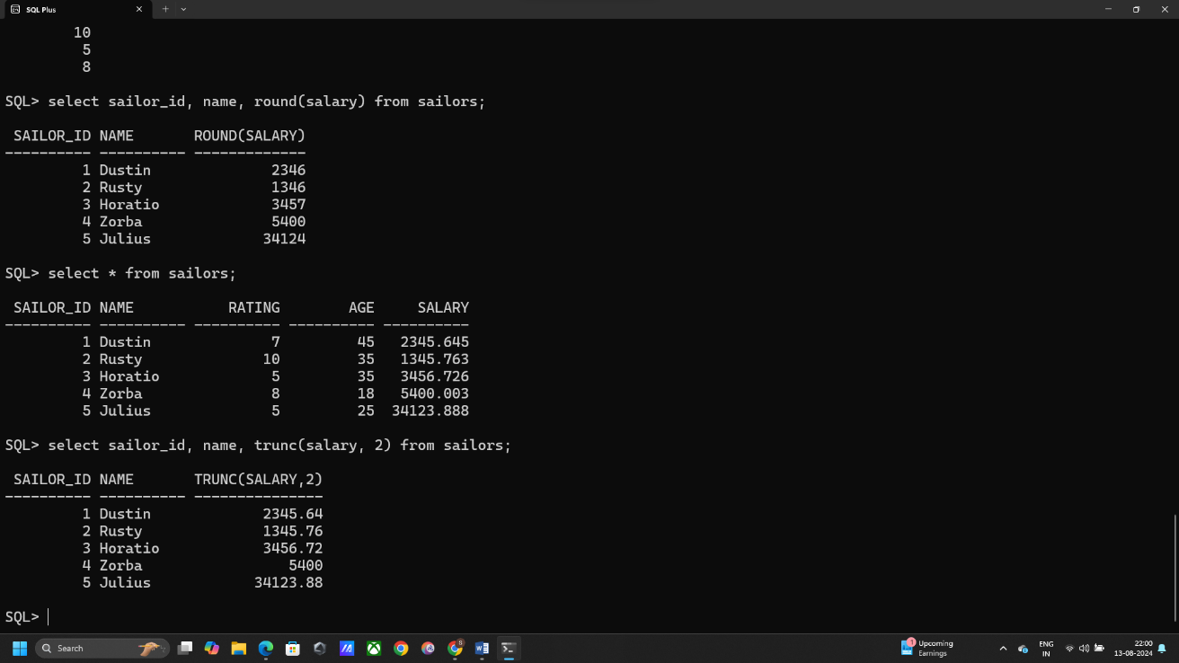select sailor_id, name, trunc(salary, 2) from sailors;

1. **Write a query to find the square of the ratings of the sailors and display it along with their names.**

select name, rating*rating as sqr_rating from sailors;

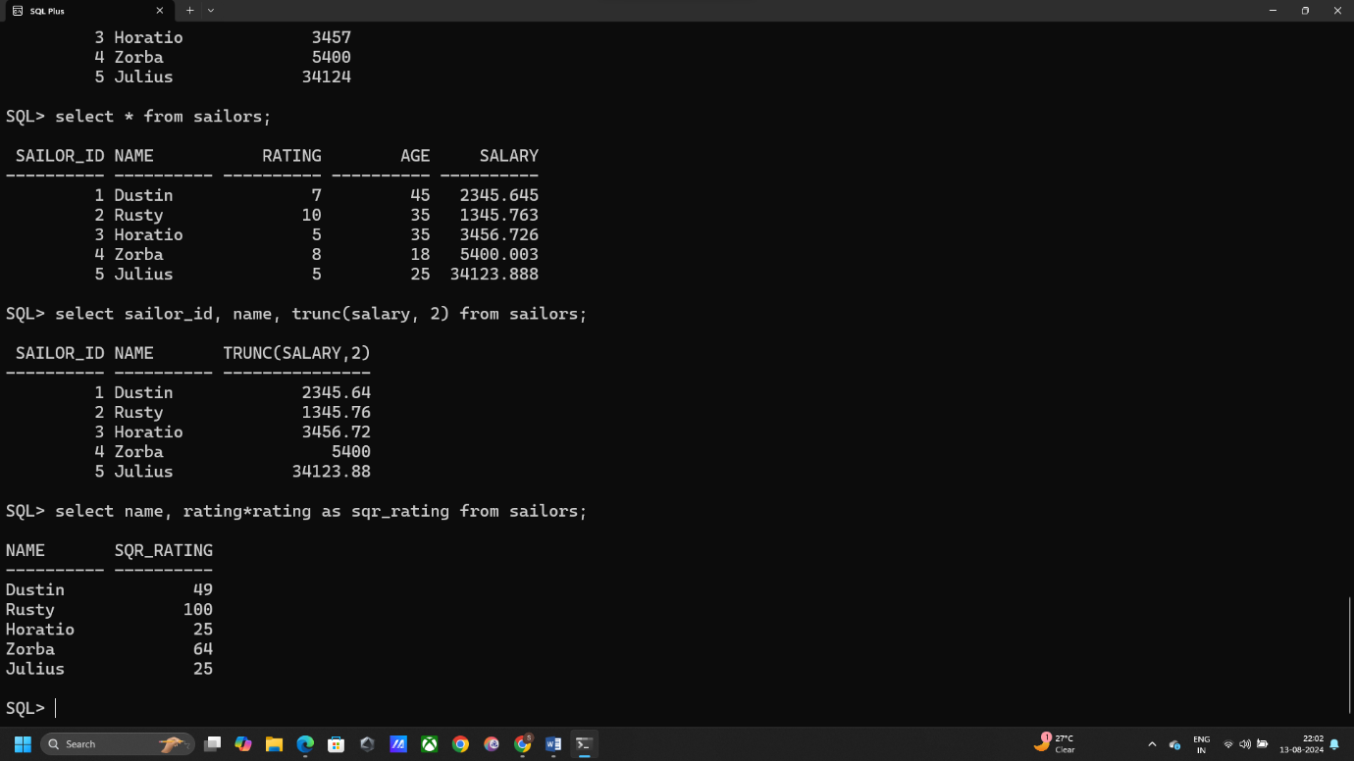

1. **Write suitable query to display all sailors with even numbered sailor id.**

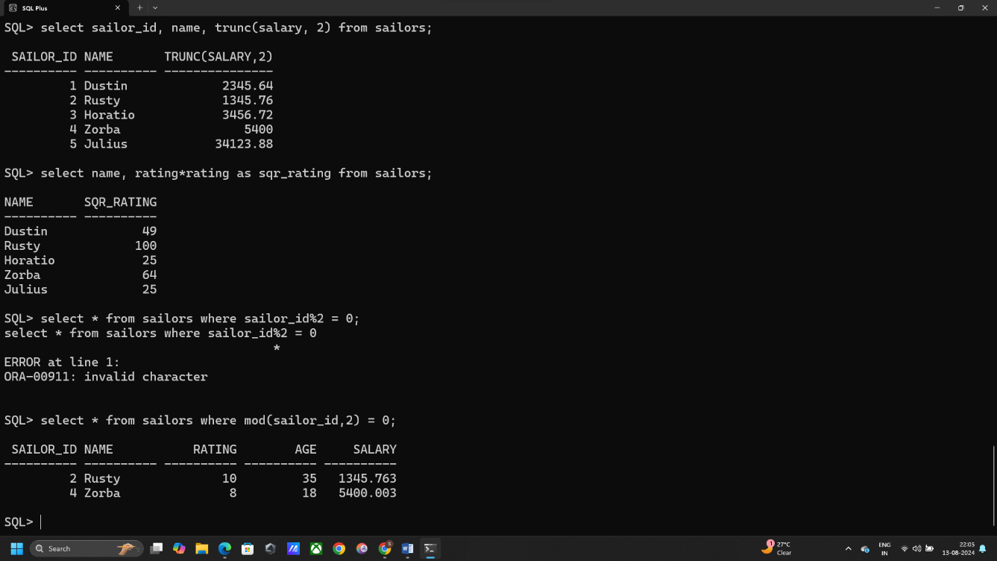SELECT * FROM SAILORS WHERE MOD(SAILOR_ID,2) = 0;

**f) Write an SQL query to find the latest date from the two dates, 11-05-1988 and 12 06-1989.**

SELECT GREATEST(TO_DATE('11-05-1988', 'DD-MM-YYYY'), TO_DATE('12-06-1989', 'DD-MM-YYYY')) AS latest_date FROM DUAL;

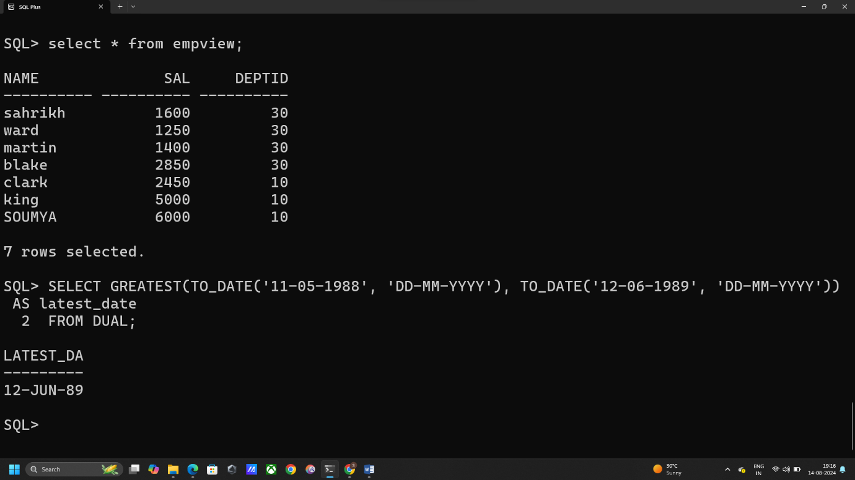

**g) Write three SQL query to round of the date 12/05/2023 16:47:00 to the nearest date, month and year formats separately.**

SELECT ROUND(TO_DATE('12/05/2023 16:47:00', 'DD/MM/YYYY HH24:MI:SS'), 'DD') AS rounded_date FROM DUAL;

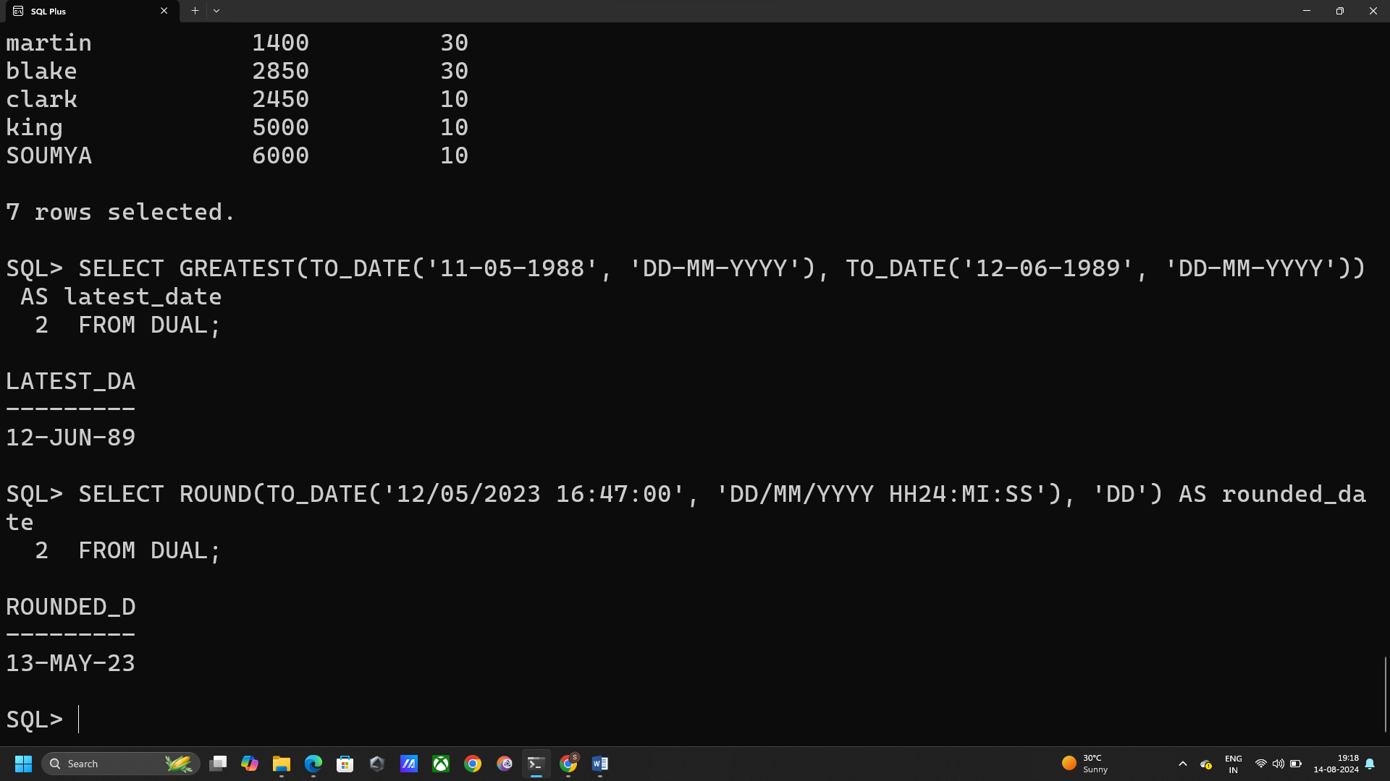

**h) Find the number of months between the two dates 23-05-1985 and 24-11-2020.**

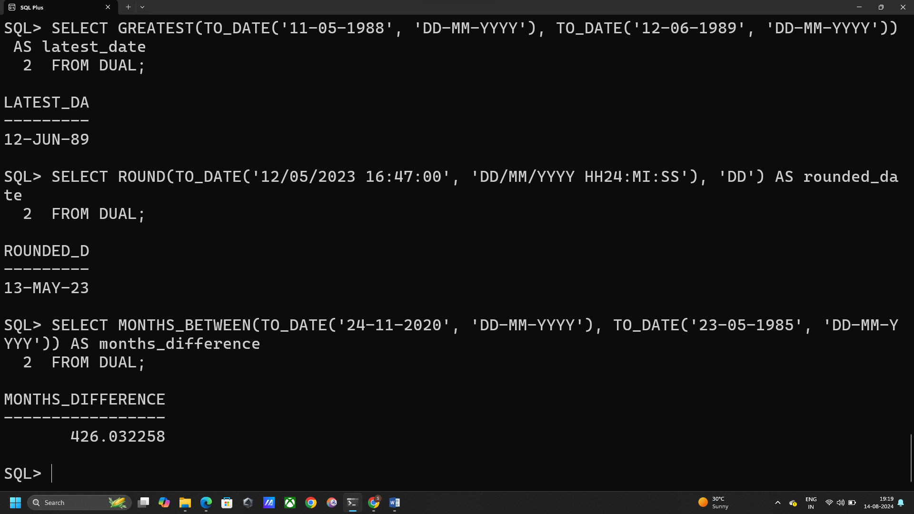SELECT MONTHS_BETWEEN(TO_DATE('24-11-2020', 'DD-MM-YYYY'), TO_DATE('23-05-1985', 'DD-MM-YYYY')) AS MONTHS_DIFFERENCE FROM DUAL;

1. **Write a query to display the remainder when each sailors's salary is divided by 100.**

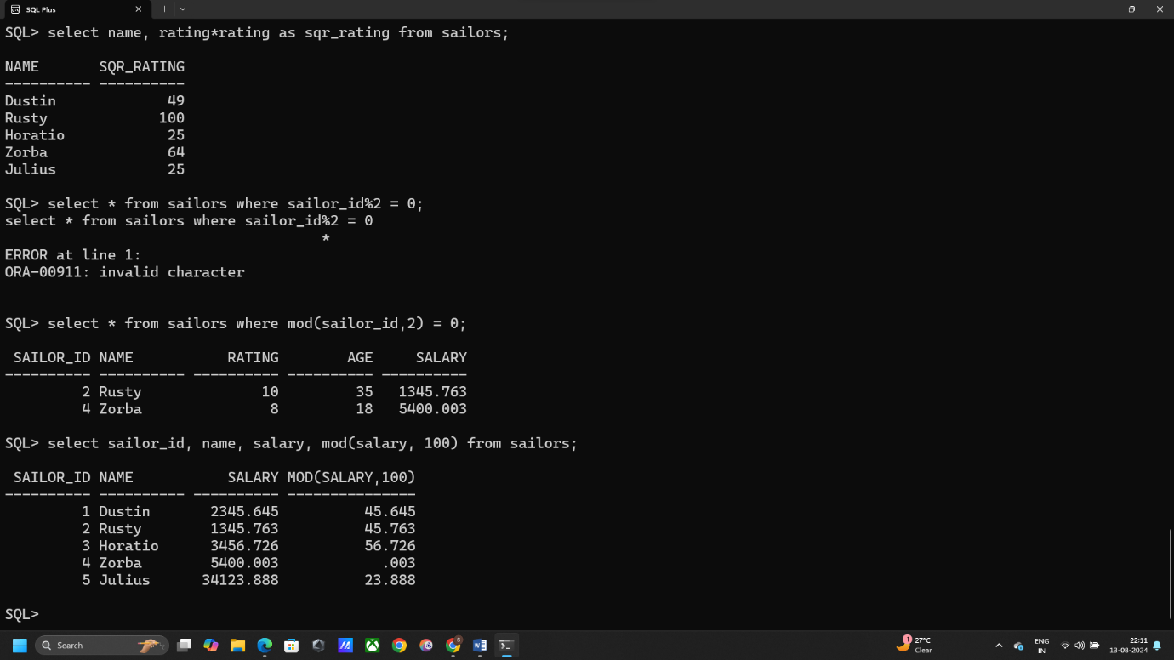select sailor_id, name, salary, mod(salary, 100) from sailors;

1. **Change all lower-case letters in the names of the sailors to uppercase and display Ans: UPDATE sailors SET name = UPPER (name);**

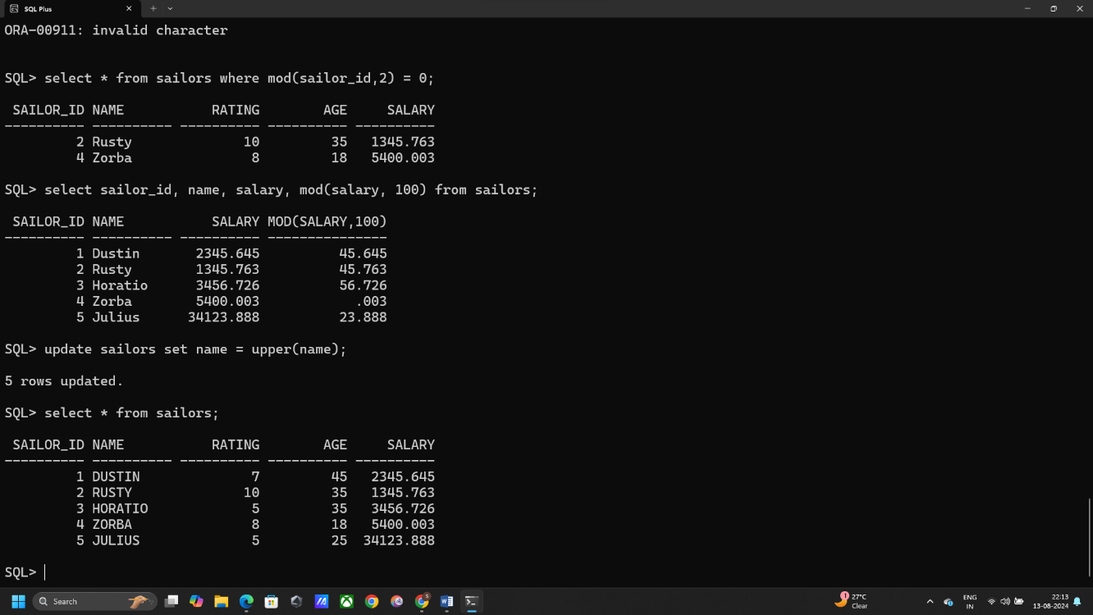 update sailors set name = upper(name);

**k. Find the sailor with the longest name using SQL query.**

SELECT NAME FROM SAILORS ORDER BY LENGTH(NAME) DESC FETCH FIRST 1 ROW ONLY;

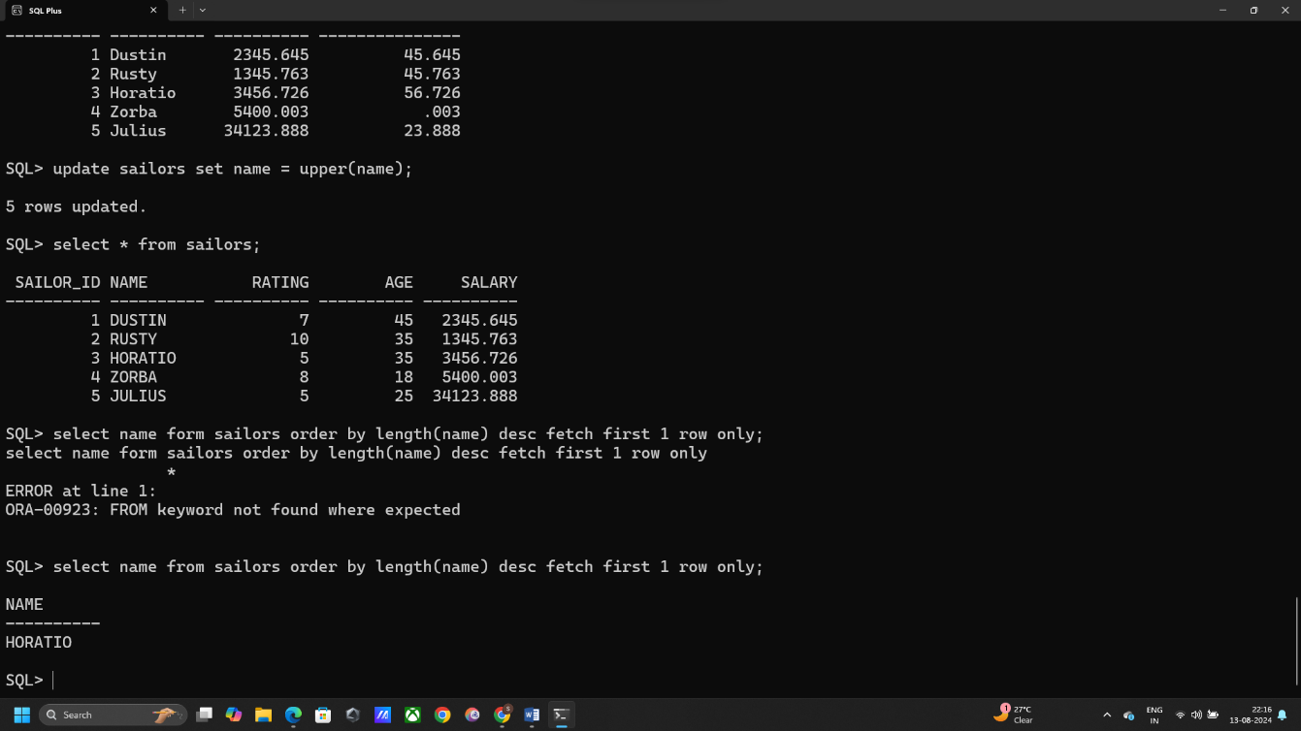

1. **Concatenate the name and age of a sailors and display the results.**

SELECT CONCAT(NAME, AGE) AS NAME_AGE FROM SAILORS;

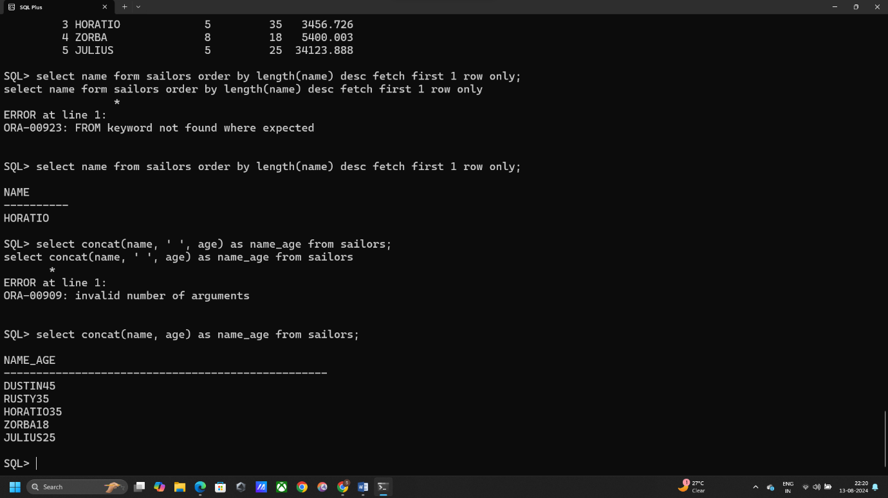

**Q3. From the table created in Q1.**

1. **Create a view Empview with the columns name salary and deptno.**

CREATE VIEW EMPVIEW AS SELECT NAME, SAL, DEPTID FROM EMPLOYEES;

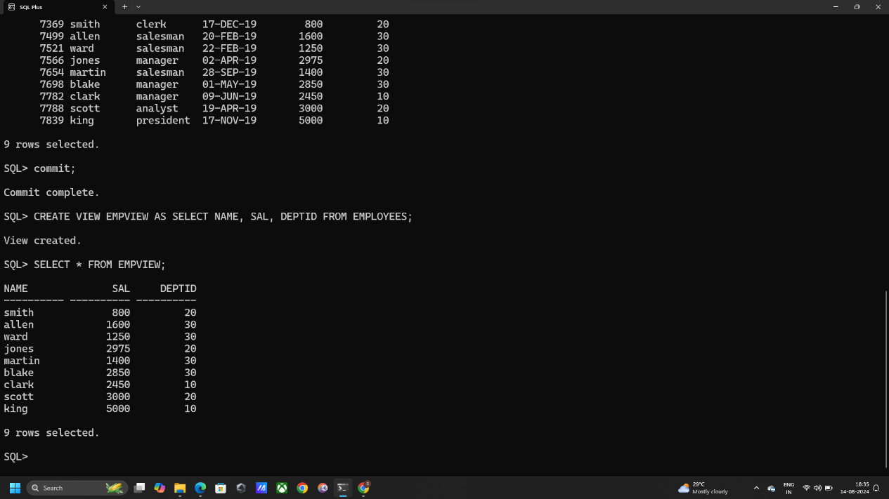SELECT * FROM EMPVIEW;

1. **Create a view Empview 1 in read only mode.**

CREATE VIEW EMPVIEW1

AS SELECT NAME, SAL, DEPTID FROM EMPLOYEES WITH READ ONLY;

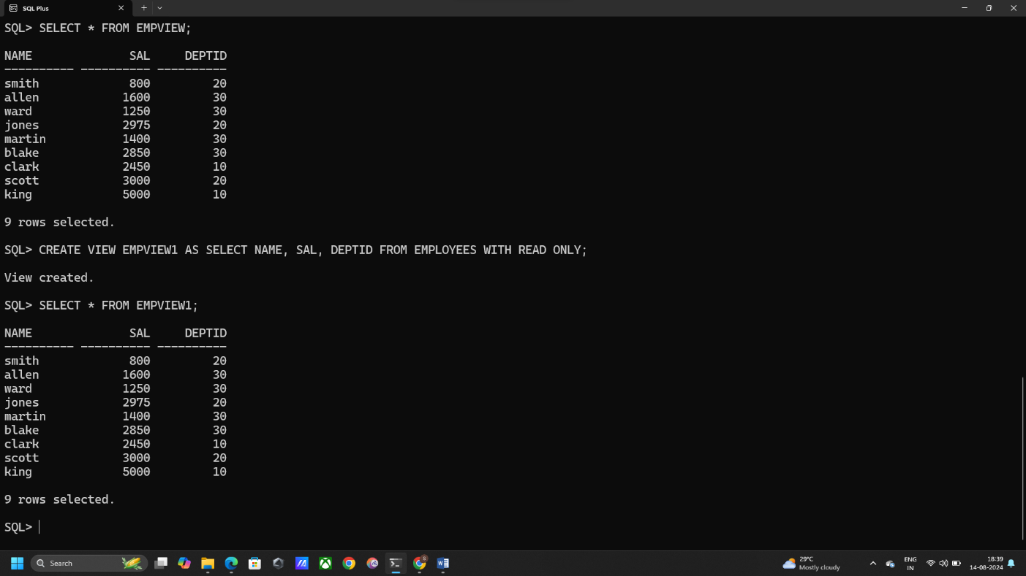SELECT * FROM EMPVIEW1;

**c) Add a tuple to your view Empview and Empview1 and check the outputs.**

**Inserting to EMPVIEW:**

INSERT INTO EMPVIEW VALUES ('SOUMYA', 6000, 10);

**Inserting to EMPVIEW1:**

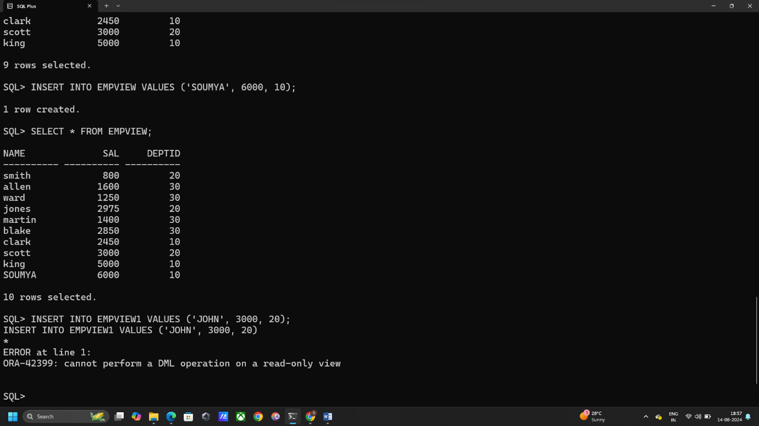INSERT INTO EMPVIEW1 VALUES ('JOHN', 3000, 20);

**d) Check the table EMPLOYEES whether the tuple you added to Empview is added or not.**

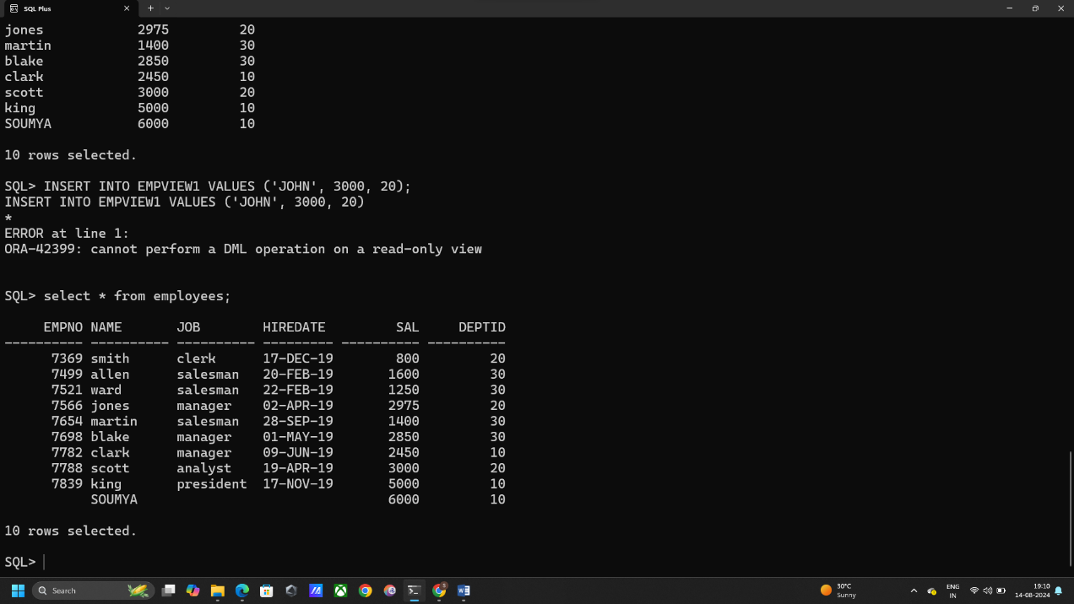SELECT * FROM EMPLOYEES;

**e) Delete tuples from the view Empview where deptno is 20;**

DELETE FROM EMPVIEW WHERE DEPTID = 20;

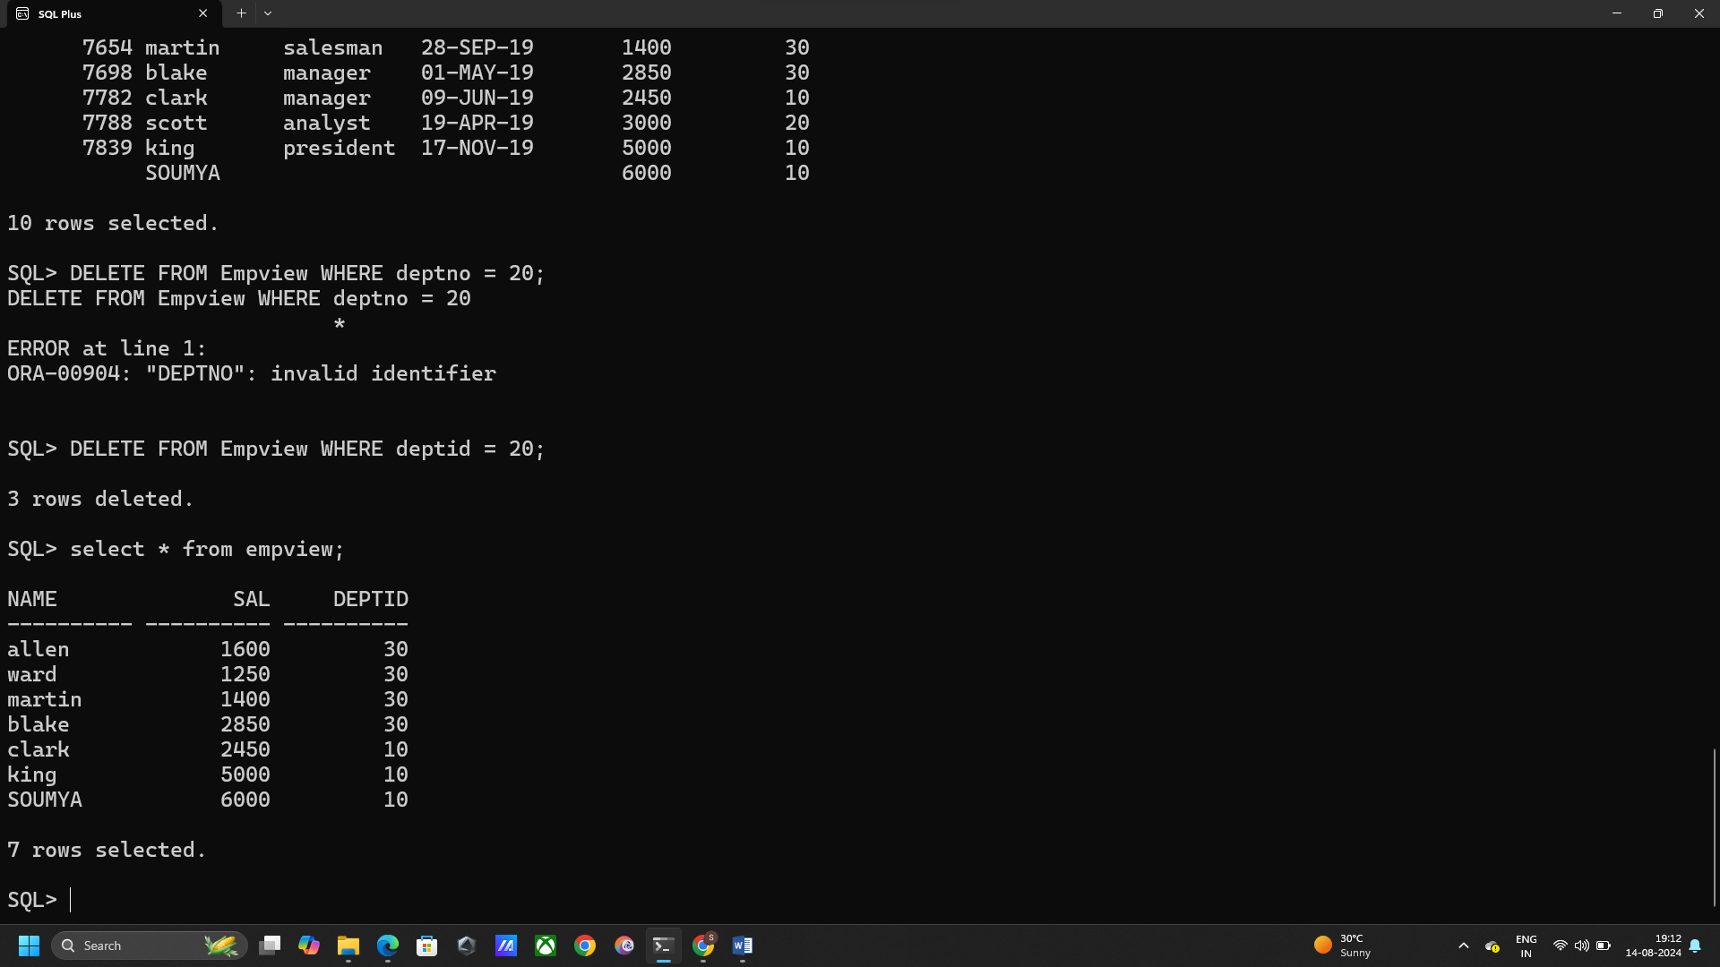

**f) Modify the tuple with name Allen as Sahrikh in the view Empview.**

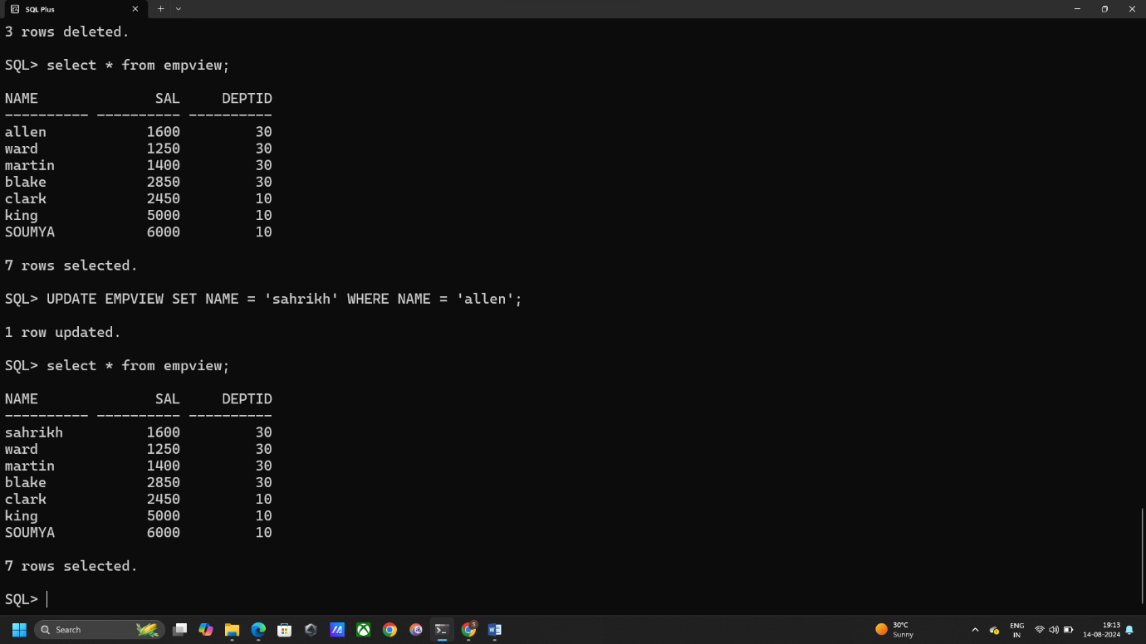UPDATE EMPVIEW SET NAME = 'sahrikh' WHERE NAME = 'allen';